DFT EDUCATIONAL TRUST
QUESTIONS BANK
DESIGN OF MACHINE ELEMENTS
UNIT-1(STEADY STRESSES AND VARIABLE STRESSES IN MACHINE MEMBERS)
PART - A
- Define ‘ Design’ and explain the design process
- What is ‘innovative design”?
- Explain a method of reducing cost of the final product from the design perspective.
- What is ‘optimization’? What are the methods for optimization?
- Define factor of safety. What factor dictate the selection of factor of safety?
- Differentiate between hardness and toughness of materials.
- Explain ‘ creep’, resilience’.
- List the various types of loads and explain.
- Distinguish between different types of variable stresses.
- Explain endurance limit. What factors influence endurance strength?
- Explain the effect of product reliability on endurance strength.
- State the significance of S-N curve.
- Define stress intensity factor.
- Explain Goodman and Seidenberg diagrams
- Differentiate between the use of Goodman diagram and Seidenberg diagram for designing.
- Comment on the statement “ In curved beams maximum stress always occurs at the inner fibre “.
- What is stress concentration? What are the methods to determine it? What are
the methods to reduce it?
- Explain how the maximum shear stress theory is used for biaxial and trysail stress cases.
- Define fatigue stress concentration factor.
- Define Notch sensitivity factor.

PART - B
- A bar of circular cross section is subject to alternating tensile forces varying from 200kN to 500kN. Material’s ultimate tensile strength is 900Mpa, endurance limit is 700Mpa. Determine the diameter of the bar using safety factors of 3.5 related to ultimate strength and 4 related to ultimate strength and 4 related to ultimate strength and 4 related to endurance limit. Stress concentration factor us 1.65 use Goodman criteria.
- A steel bar is subjected to a reversed axial load of 180kN. Find the diameter of the bar for a design factor of 2. Ultimate tensile strength 1070N/mm2 yield strength 910N/mm2 . Endurance limit in bending is half of ultimate tensile strength. Use the following data. Load factor 0.7, Surface finish factor 0.8, Size factor 0.85, and stress concentration factor 1.
- A steel cantilever beam 180mm long has a diameter ‘d’ for a length of 125mm from the free end and ‘2d’ for the remaining length. A fillet of radius 0.2d is provided at the junction of the two sections. A transverse load varying from
4N up and 135N down is acting in combination with an axial load that varies from- 110N to + 450N . Using a design factor of 2, calculate the diameter at the fillet section for infinite life. Ultimate strength 550Mpa, yield strength 470Mpa, Endurance limit 275Mpa. Size factor 0.85 surface factor 0.9 stress concentration factor for bending 1.44, for axial load 1.63 .
- A Punch frame has shape and loading as shown. Determine the stress developed.
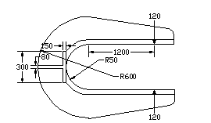
- A C Clamp is acted upon by a load of 20kN as shown in figure. The clamp has a square cross section throughout the length And is made of a materials with an allowable tensile stress of 150Mpa. Determine the side of the square cross section. Determine the stress developed at section BB.
- (a) A piston of a reciprocating compressor has a diameter of 60mm. The maximum pressure on the piston fall is 1.25MN/m2.Assuming the gudgeon pin passing through the small end of the connecting rod can be safely loaded in shear up to 10MN/m2, Calculate the minimum diameter of the gudgeon pin.(b) Explain with mathematical expressions.Maximum principal stress theory and Von-Mises-Henky theory.
- Determine the diameter of the steel bar, which is a ductile in a nature subjected to an axial load of 60KN and torsional moment of 1600N-m.Use the
factor of safety 2.5.E=200GPa.(b) Explain with mathematical expressions.Maximum shear theory and Venant's theory.
- A steel member is subjected to a 3-D stress system and resulting principal stress are 120N/mm2 tension, 80N/mm2and 40N/mm2 compression. If the proportional limit of the material in simple tension is 280N/mm2 and its poison's ratio is O.3.Determine the factor of safety according to (a) Maximum principal stress theory (b) Maximum principal strain theory (c) Maximum shear stress theory.
- A bolt is subjected to a tensile load of 25KN and a shear load of 10KN. Determine the diameter of the bolt according to (a) Maximum principal stress theory (b) Maximum principal strain theory (c)Maximum shear stress theory. Assume factor of safety 2.5, Yield point stress in simple tension 300N/mm2, Poisson's ratio is 0.25.
- A mild steel bracket as shown in fig. is subjected to a pull of 6000N acting at 45° to its horizontal axis. The bracket has a rectangular cross section whose depth is twice the thickness.Find the cross sectional dimensions of the bracket, if the permissible stress in the material of the bracket is limited to 60MPa.

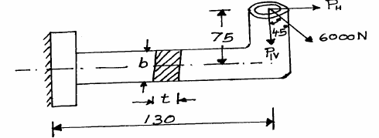
- A cantilever rod of circular cross section is subjected is subjected to a cyclic transverse loadvarying from -100N to +300N as shown in fig. Determine the diameter ‘d’of the rod by (i) Goodman method (ii) Soderberg method using following data
Factor of safety = 2
Theoretical stress concentration factor = 1.4
Notch sensitivity factor = 0.9
Ultimate strength = 550Mpa
Yield strength = 320MPa
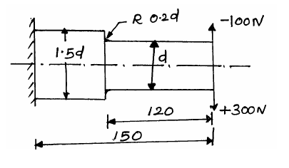
- A plate 12mm thick with two holes as indicated in fig. is subjected to tensile load of 20KN.Calculate the stresses at both holes.
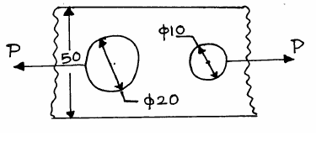
- The bending stress in a machine part fluctuates between a tensile stress of 280N/mm2 and a compressive stress of 140N/mm2.What should be the minimum ultimate tensile strength of this part to carry this fluctuation indefinitely according to (i) Goodman’s formula (ii) Soderberg formula Factor of safety is 1.75.Assume that the yield point is never likely to be less than 55% of the ultimate tensile strength or greater than 93% of it.
- A C –clamp is subjected to a maximum load of W,as shown in figure.If the maximum tensile stress in the clamp is limited to 140MPa.Find the value of load w.
- A crane hook has a section as shown in figure. It is made of plain carbon steel with an yield strength of 380MPa.Determine the load capacity of the hook,for a factor of safety of 3.
- A crank shaft bearing is loaded as shown in fig. Determine the maximum principal stress, minimum principal stress and maximum shear stress.

.

.

UNIT - II - (DESIGN OF SHAFTS, KEYS AND COUPLINGS)
PART - A
1. What is shaft?
2. What are the types of shafts?
3. List all the shaft materials.
4. What is simple torsion?
5. What is simple bending moment?
6. Write down the formula for finding equivalent twisting moment.
7. What are types of rigidity?
8. What are different measures followed to control the lateral deflection?
9. What are the different ways to limit the maximum permissible transverse deflection?
10. Define the term critical speed.
11. Write down the dunkerley’s equation for the critical speed of the shaft.
12. What is key?
13. What are types of keys?
14. How are sunk keys designed?
15. What is the main use of woodruff keys?
16. How is a couplings specified?
17. What are the purposes in machinery for which couplings are used?
18. Name any two of the rigid and flexible couplings?
19.What is material used for flange or flange couplings?
20.What is the advantage of Gear coupling?

PART – B

- A line shaft rotating at 200rpm is to transmit 20KW power. the allowable shear stress for the shaft material is 42N/mm2.If the shaft carries a central load of 900N and is simply supported between bearing 3meters apart determine the diameter of the shaft. The maximum tensile or compressive stress is not to exceed 56N/mm2.
- An electric generator rotates at 200rpm and receives 300KW from the driving engine. The armature of the generator is 60cm long and located between bearing 120cm center to center.Owing to the combined weight of armature and magnetic pull, the shaft is subjected to 9000kg acting at right angles to the shaft. The ultimate stress for the shaft is 4480kg/cm2 and shear stress is 3920kg/cm2.Find the diameter of the shaft for a factor of safety of 6.
- A mild steel shaft transmit 23KW to 200rpm.It carries a central load of 900N and is simply supported between the bearing 2.5meters apart. Determine the size of the shaft, if the allowable shear stress is 42MPa and the maximum tensile or compressive stress is not exceed 56MPA.What size of the shaft will be required, if it is subjected to gradually applied load?
- A shaft to transmit 50KW at 1200rpm.It is also subjected to a bending moment of 275Nm.Allowable shear stress is 60N/mm2.The shaft is not to twist more than 2° in a length of 2m.G=80X103N/mm2.Design a shaft.
- A factory line shaft is 4.5m long and is to transmit 75KW at 200rpm.The allowable stress in shear is 49MPa and maximum allowable twist is 1° in a length of 20mm diameter. Determine the required shaft diameter.
- A solid shaft is to transmit 1000KW at 120rpm.Find the shaft diameter if the design shear stress is 80N/mm2.If the shaft is made hollow with internal diameter is 0.6 times the outside diameter, find the percentage of saving material.
- A solid shaft to transmit power from an electric motor to a machine through a pulley by means of a vertical belt drive with unit speed ratio. The pulley weights 250N and is overhanging at a distance of 120mm from the bearing. Diameter of the pulley is 200mm.Maximum power transmitted at 150rpm is 3KW.Coefficient of friction between the belt and the pulley is 0.25.Combined shock and fatigue factor in torsion is 1.5 and in bending is 2.0,permissible shear stress for the shaft material is 40N/mm2.Design the shaft.Standared diameter from R20 series in mm are:20,22.4,25,28,31.5,40,45,50,56,63,71&80.
- A line shaft supporting two pulleys A and B is shown in fig. Power is supplied to the shaft by means of vertical belt on pulley A, Which is then transmitted to pulley B carrying a horizontal belt. The ratio of the belt tensions on tight and loose side is 3:1 and the maximum tension in either belt is limited to 2.7KN.The shaft is made of plain carbon steel 40C8 (Sut=650N/mm2 and Syt=380N/mm2).The pulleys are keyed to the shaft. Determine the shaft diameter according to the A.S.M.E code if Kb=1.5 and Kt=1.0.
- (a)Determine the dimensions of the rectangular sunk key made up of mild steel for a 80mm diameter mild steel shaft to transmit to torque of 135N-m.Assume
τ =50N/mm2 and σ c=120N/mm2.
(b)Design a taper key for a shaft of diameter 100mm transmitting 60KW at 300rpm.
The allowable compressive stress may be taken as 175N/mm2.
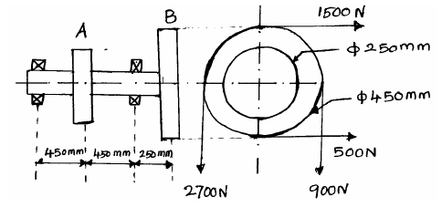
10. Design and draw a cast iron flange coupling for a mild steel shaft transmitting 90KW
at 250rpm.The allowable shear stress in the shaft is 40MPa and the angle of twist is not to
exceed 1° in a length of 20 diameters. The allowable shear stress in the coupling bolt is
30MPa.

11. Design a cast iron protective type flange coupling to transmit 15KW at 900rpm from
an electric motor to a compressor. The service factor may be assumed as 1.35.

The following permissible stress may be used:
Shear stress for the shaft, bolt and key material=40MPa
Crushing stress for bolt and key=80Mpa
Shear stress for cast iron=8Mpa

12. A rigid type coupling is used to connect two shaft transmit 15KW at 200rpm.The shaft, key
and bolts are made of C45 steel and the coupling is of C.I.Design the coupling.

13. Design and sketch protective type C.I flange coupling to transmit 10KW at 250rpm.
The permissible shear stress for key, shaft, bolt as 50N/mm2.Take crushing stress of key
as 90N/mm2 and shear stress for C.I as 14N/mm2.Assume maximum torque is 30% higher
than mean torque.

14. Two 35mm shaft are connected by a flange coupling. The flange are fitted with 6 bolts on 25mm bolt circle. The shaft transmit a torque of 800 Nm at 350rpm. For the safe stresses mentioned below, calculate (i) diameter of bolt (ii) thickness of flange (iii) key dimension (iv) hub length and (v) power transmitted. Safe stress for shaft material 63MPa, bolt material 56MPa, cast iron coupling 10MPa and for key material 46MPa.

15. Design a cast iron protective type flange coupling to transmit 15KW at 900rpm from an electric motor to a compressor. The service factor may be assumed as 1.35.
The following permissible stress may be used:
Shear stress for the shaft, bolt and key material=40MPa
Crushing stress for bolt and key=80Mpa
Shear stress for cast iron=8Mpa.

16. Design and make a neat dimensional sketch of a muff coupling which is used to connect two steel shafts transmitting 40 kW at 350rpm. The material for the shaft and key is plain carbon steel for which allowable shear and crushing stresses may be taken as 40MPa and 80MPa respectively. The material for muff is cast iron for which the allowable shear stress may be assumed as 15MPa.

