**13**

DE–2968

DISTANCE EDUCATION

B.Sc. DEGREE EXAMINATION, MAY 2008.

Mathematics

CLASSICAL ALGEBRA

Time : Three hours Maximum : 100 marks

Answer any FIVE questions.   
 (5 × 20 = 100)

1. (a) (i) Prove that Every convergent sequence is a Cauchy sequence.
2. (ii) Show that 
3. (b) Discuss the behaviour of the geometric sequence .
4. (a) State and prove Cauchy’s General principles of convergence theorem.
5. (b) (i) Test the convergence of the series 
   1. (ii) Prove that the series
   2.  is an oscillating series.
6. (a) (i) Sum to infinity the series
7. 
   1. (ii) Show that
   2. .
8. (b) (i) Show that 
   1. (ii) Prove that
   2. 
9. (a) Find the sum to Infinity the series
10. 
11. (b) When *n* is large show that
12. nearly.
13. (a) (i) Show that the equation
14. 
    1. Where p,q,r, a, b, c and k are real has no imaginary roots.
    2. (ii) One root of the equation
    3. is  find the remaining roots.
15. (b) Show that the roots of the equation  are in arithmetic progression iff . Hence solve .
16. (a) (i) Show that the sum of the  power of the roots equation  where
    1. (ii) Transform the equation in to one in which the second term is missing and hence solve the given equation.
17. (b) If the equation has three equal roots prove that (i)  (ii)
18. (a) (i) Prove that
19. 
    1. (ii) If  are three distinct positive real numbers then prove that 
20. (b) (i) Prove that   
     
    1. (ii) Show that
    2. 
21. (a) If and 
22. Verify that where  is the transpose of A.
23. (b) Verify the statement that the sum of the elements in the diagonal of a matrix is the sum of the eigen values of the matrix .

——————



**14**

DE–2969

DISTANCE EDUCATION

B.Sc. (Mathematics) DEGREE EXAMINATION, MAY 2008.

CALCULUS

Time : Three hours Maximum : 100 marks

Answer any FIVE questions.

All questions carry equal marks.

1. (a) If , prove that

.

* 1. (b) If , show that

.

1. (a) Prove that the maximum rectangle inscribed in a circle is a square.
   1. (b) Find the radius of curvature at any point of the curve , .
2. (a) Evaluate .
   1. (b) Evaluate .
3. (a) Prove that  and evaluate .
   1. (b) Obtain the reduction formula for .
4. (a) Solve : .
   1. (b) Solve : .
5. (a) Solve : .
   1. (b) Solve : .
6. (a) Evaluate  by using Laplace transform.
   1. (b) Find .
   2. (c) Solve : , .
7. (a) Eliminate *f* and ** from .
   1. (b) Obtain a complete integral of

.

———————



**15**

DE–2970

DISTANCE EDUCATION

B.Sc. DEGREE EXAMINATION, MAY 2008.

Mathematics

ANALYTICAL GEOMETRY AND VECTOR CALCULUS

Time : Three hours Maximum : 100 marks

Answer any FIVE questions.

1. (a) (i) Show that the equation of the pair of straight lines each inclined at an angle of 45° to one or other   
   of the lines given by the equation  is .
   1. (ii) For what value of *k* does  represent a pair of straight lines? Also write down the separate equations to the lines.
   2. (b) Find the equation of the radical axis of the two circles  and and show that it is at right angles to the line joining the centres of the two circles.
2. (a) Find the equation to the two circles that cut orthogonally the circles  and touch the line  and find the distance between their centres.
   1. (b) Show that in a conic the semi-latus rectum is the harmonic mean between the segments of a focal chord.
3. (a) Show that the straight lines whose D.C's are given by the equations  and  are perpendicular if  and are parallel if .
   1. (b) A moving plane passes through a fixed point  are intersects the coordinates axes at *A*, *B*, *C* show that the locus of the centroid of the  *ABC* is .
4. (a) Find the equations of the image of the line  in the plane .
   1. (b) Show that the lines  and  are coplanar. Find the point of intersection and the equation of the plane in which they lie.
5. (a) Find the shortest distance and the equation of the line of shortest distance in symmetric form of the lines  and .
   1. (b) Find the equation of the sphere passing through the points (1, 1, –2), (–1, 1, 2) and having the centre of the sphere on the line , .
6. (a) Find the equation of the sphere having the circle   as a great circle. Also find its centre and radius.
   1. (b) A sphere of constant radius r always passes through the origin and meets the coordinate axes in A, B, C prove that the locus of the centroid of the triangle ABC is the sphere .
7. (a) (i) If  find  if .
   1. (ii) Show that curl .
   2. (b) Prove that  is solenoidal as well as irrotational. Also find the scalar potential of .
8. (a) Evaluate  where  and the curve *C* is the rectangle in *xy* plane bounded by .
   1. (b) Verify Gauss Divergence theorem for  for the cylindrical region *S* given by  and .

–––––––––––



DE–2971

**23**

DISTANCE EDUCATION

B.Sc.(Mathematics) DEGREE EXAMINATION, MAY 2008.

MECHANICS

Time : Three hours Maximum : 100 marks

Answer any FIVE questions.  
 (5 × 20 = 100)

1. (a) Derive the analytical expression for the resultant of two forces.
   1. (b) ABC is a given triangle. Forces *P*, *Q*, *R* acting along the lines *OA*, *OB*, *OC* are in equilibrium. Prove that  if *O* is the orthocentre of the triangle.
2. (a) Find the magnitude and direction of the resultant of any number of coplanar forces acting at a point of analytical method.
   1. (b) *ABCDEF* is a regular hexagon and at *A*, act forces represented by , , ,  and . Show that the magnitude of the resultant is  and that it makes an angle  with *AB*.
3. (a) Find the resultant of two like parallel forces acting on a rigid body.
   1. (b) Prove that the algebraic sum of the moment of two forces about any point in their plane is equal to the moment of their resultant about that point
4. (a) Explain the following :
   1. (i) Statical, dynamical and limiting friction
   2. (ii) Coefficient of friction
   3. (iii) Angle of friction.
   4. (b) A particle of weight 30 kgs. resting on a rough horizontal plane is just on the point of motion when acted only horizontal forces of 6 kg. wt. and 8 kg. wt. at right angles to each other. Find the coefficient of friction between the particle and the plane and the direction in which the friction acts.
5. (a) Show that the greatest height which a particle with initial velocity *v* can reach on a vertical wall at a distance ‘*a*’ from the point of projection is .
   1. (b) Find the range of a projectile on an inclined plane for a given velocity of projection and angle of projection.
6. (a) A short of mass *m* penetrates a thickness *t* of a fixed plate of mass *M*. If *M* were free to move and the resistance supposed to be uniform, show that the thickness penetrated is .
   1. (b) Find the loss of kinetic energy due to direct impact of two spheres of masses  and  moving along a straight line with velocities  and .
7. (a) The equation of a simple harmonic motion is . Find *x* interms of *t*.
   1. (b) Show that the resultant motion of two simple harmonic motions of the same period in two perpendicular directions is along an ellipse.
8. (a) Obtain the equation to the central orbit in the form .
   1. (b) Find the pedal equation to the following curves :
   2. (i) Parabola whose pole at the focus
   3. (ii) Ellipse whose pole at the focus.

———————

**24**

DE-2972

DISTANCE EDUCATION

B.Sc. DEGREE EXAMINATION, MAY 2008.

Mathematics

ANALYSIS

Time : Three hours Maximum : 100 marks

Answer any FIVE questions.

All questions carry equal marks.

1. (a) (i) Define a metric space. (5)
   1. (ii) Let  with  . Define  +  then prove that *d* is metric on *R*. (5)
   2. (b) Prove that in any metric space the intersection of a finite number of open sets is open. (10)
2. (a) Let  be a metric space. Let  then prove that *A* is open iff . (10)
   1. (b) Let *M* be a metric space and  then prove that . (10)
3. (a) State and prove intermediate value theorem.   
    (5 + 5 = 10)
   1. (b) State and prove Baire's Category theorem.  
       (5 + 5 = 10)
4. (a) State and prove Cantor's intersection theorem. (15)
   1. (b) Prove that any non-empty open interval  in *R* is of second category. (5)
5. (a) State and prove Heine Borel theorem. (10)
   1. (b) Prove that any continuous image of a compact metric space is compact. (10)
6. (a) Prove that a closed subspace of a compact metric space is compact. (10)
   1. (b) Define uniform continuity. Prove that  defined by  is uniformly continuous on [0, 1]. (10)
7. (a) Define uniform convergence  defined by   for all  the prove that the convergence is not uniform. (10)
   1. (b) State and prove Cauchy's criterion for uniform convergence. (10)
8. (a) State and prove contraction mapping theorem. (10)
   1. (b) State and prove Picards theorem. (10)

————————

**25**

DE–2973

DISTANCE EDUCATION

B.Sc.(Maths) DEGREE EXAMINATION,MAY 2008.

PROBABILITY AND STATISTICS

Time : Three hours Maximum : 100 marks

Answer any FIVE questions.

1. (a) Define conditional probability. (5)
   1. (b) Explain two types of radom variables. (5)
   2. (c) The chances that 4 students A,B,C,D solve a problem are , , ,  respectively. I fall of them solve the problem, what is the probability that the problem is solved. (10)
2. (a) Find the mean and standard deviation for the following frequency distribution.

|  |  |  |  |  |  |  |  |  |  |  |
| --- | --- | --- | --- | --- | --- | --- | --- | --- | --- | --- |
| Marks: | 10 | 9 | 8 | 7 | 6 | 5 | 4 | 3 | 2 | 1 |
| Frequency: | 1 | 5 | 11 | 15 | 12 | 7 | 3 | 3 | 0 | 1 |

* 1. (b) Find
  2. (i) The constant K such that the function

 is a probability function.

* 1. (ii) Find the distribution function.

1. (a) Fit a curve of the form  to the following data.

|  |  |  |  |  |  |  |
| --- | --- | --- | --- | --- | --- | --- |
| *x*: | 1 | 2 | 3 | 4 | 5 | 6 |
| *y*: | 1200 | 900 | 600 | 200 | 110 | 50 |

* 1. (b) Find the rank correlation coefficient between height in c.m and weight is kg of 6 solidiers in Indian army.

|  |  |  |  |  |  |  |
| --- | --- | --- | --- | --- | --- | --- |
| Height: | 165 | 167 | 166 | 170 | 169 | 172 |
| Weight: | 61 | 60 | 63.5 | 63 | 61.5 | 64 |

1. (a) Derive the formula for rank correlation coefficient.
   1. (b) If  and  are the regression lines of  
      *x* on *y* and *y* on *x* respectively,
   2. (i) Show that 
   3. (ii) If , find the means of tub variables *x* and and *y*  and the correlation coefficient between them.
2. (a) Derive recurrence relation for central moments of binomial distribution.
   1. (b) Between the hours 2 p.m and 4 p.m the average number of phone calls per minute coming into the switch board of a company is 2.35. Find the probability that during one particular minute there will be at most 2 phone calls.
3. (a) Prove that the moment generating function about the origin of the normal distribution is .
   1. (b) In a normal distribution 31% of the items are under 45 and 85% are over 64. Find the mean and standard deviation.
4. (a) A machine puts out 16 imperfect articles in a sample of 500 articles. After the machine is overhanded it puts out 3 defective articles in a sample of 100. Has the machine improved? (8)
   1. (b) Analyse the variance in the following Latin Square.   
       (12)

|  |  |  |
| --- | --- | --- |
| A8 | C18 | B9 |
| C9 | B18 | A16 |
| B11 | A10 | C20 |

1. (a) Of 500 men in a locality exposed to cholera 172 in all were attacked; 178 were inoculated and of these 128 were attacked. Find the number of persons.
   1. (i) Not inoculated not attacked.
   2. (ii) inoculated not attacked
   3. (iii) Not inoculated attacked
   4. (b) Calculate
   5. (i) Laspeyre’s
   6. (ii) Paache’s
   7. (iii) Fisher’s index numbers for the following data given data
   8. Hence find Bowley’s index number.

|  |  |  |  |  |
| --- | --- | --- | --- | --- |
| Commodities | Base year | | Current year | |
|  | Price | Quantity | Price | Quantity |
| A | 2 | 10 | 3 | 12 |
| B | 5 | 16 | 6.5 | 11 |
| C | 3.5 | 18 | 4 | 16 |
| D | 7 | 21 | 9 | 25 |
| E | 3 | 11 | 3.5 | 20 |

————————

**31**

DE–2974

DISTANCE EDUCATION

B.Sc. DEGREE EXAMINATION, MAY 2008.

Mathematics

ALGEBRA

Time : Three hours Maximum : 100 marks

Answer any FIVE questions.   
 (5 × 20 = 100)

1. (a) Prove the following :
   1. (i) 
   2. (ii) .
   3. (b) Define an equivalence relation and show that the following relations  are equivalent :
   4. (i) In ,  iff  is even
   5. (ii) In ,  means .
2. (a) Find  and  for the functions
   1.  given by ,  given by .
   2. (b) (i) Find  for the function  defined as .
   3. (ii) If  and are bisections, then prove that .
3. (a) Show that the permutations   form a group and construct its Cayley’s table.
   1. (b) Let  and  be two subgroups of a group . Show that  is a subgroup of  iff .
4. (a) (i) Prove that every group of prime order is cyclic.
   1. (ii) State and prove Euler’s theorem.
   2. (b) Define kernel of a homomorphism.
   3. If  is a homomorphism, show that   
      Ker is a normal subgroup of .
5. (a) Define an integral domain and show that every finite integral domain is a field.
   1. (b) Show that  is an integral domain iff  is an integral domain.
6. (a) Let  be a commutative ring with identity ; show that  is a field iff has no proper ideals.
   1. (b) (i) Let  be a non-zero element of an Euclidean domain . Then  is a unit  iff .
   2. (ii) Let  be an Euclidean domain and . Show that  and  implies .
7. (a) Let be a vector space over a field  and . Then show that :
   1. (i) 
   2. (ii) 
   3. (iii)  iff  is a subspace of .
   4. (b)  is a linearly dependent set of vectors in  iff there exists a vector  such that  is a linear combination of the preceding vectors . Justify this statement.
8. (a) If  is a finite dimensional vector space and  is a subspace of , show that dim .
   1. (b) Define an orthogonal set and an orthonormal set. If  is an orthogonal set of non-zero vectors in an inner product space , show that  is linearly independent.

————————

**32**

DE–2975

DISTANCE EDUCATION

B.Sc. (Mathematics) DEGREE EXAMINATION, MAY 2008.

OPERATIONS RESEARCH

Time : Three hours Maximum : 100 marks

Answer any FIVE questions.

Each question carries 20 marks

1. (a) Consider two types of food stuffs say  and . Assuming that these contains Vitamins  and  respectively. Minimum daily requirements of these are   
   1 mg of , 50 mg of  and 10 mg of  suppose  contains   
   1 mg of  100 mg of  and 10 mg of  where as  contains 1 mg  10 mg of  and 100 mg of . Cost of 1 unit of  is   
   Rs. 1.00 and that of  is Rs. 1.50. Formulate this as on linear programming problem as an minimization problem. (10)

(b) Solve graphically the linear programming problem :

Maximize 

Subject to .  
 (10)

1. (a) Obtain the dual problem of the following L.P.P.

Maximize : 

Subject to : 

 (10)

(b) Use simplex method to solve the following L.P.P.

Maximize : 

Subject to .  
 (10)

1. (a) Use Charnes Penalty method to solve the following L.P.P.

Minimize : 

Subject to

. (10)

(b) Use two phase simplex method to solve the following L.P.P.

Maximize : 

Subject to

. (10)

1. (a) Find the optimal integer solution to

Maximize : 

Subject to

 are integers. (10)

(b) Write the procedure of cutting plane algorithm for the solution of all–integer programming problem. (10)

1. (a) Solve the following Transportation problem (10)

|  |  |  |  |  |
| --- | --- | --- | --- | --- |
|  | A | B | C | Available |
| I | 50 | 30 | 220 | 1 |
| II | 90 | 45 | 170 | 3 |
| III | 250 | 200 | 150 | 4 |
| Requirement | 4 | 2 | 2 |  |

(b) Solve the following transportation problem to maximize the profit. (10)

|  |  |  |  |  |  |
| --- | --- | --- | --- | --- | --- |
|  | 1 | 2 | 3 | 4 | Supply |
| A | 40 | 25 | 22 | 33 | 100 |
| B | 44 | 35 | 30 | 30 | 30 |
| C | 38 | 38 | 28 | 33 | 70 |
| Demand | 40 | 20 | 60 | 30 |  |

1. (a) Solve the following assignment problem : (10)

|  |  |  |  |  |  |
| --- | --- | --- | --- | --- | --- |
|  | A | B | C | D | E |
| 1 | 32 | 38 | 40 | 28 | 40 |
| 2 | 40 | 24 | 28 | 21 | 36 |
| 3 | 41 | 27 | 33 | 30 | 37 |
| 4 | 22 | 38 | 41 | 36 | 36 |
| 5 | 29 | 33 | 40 | 35 | 39 |

(b) Solve the following assignment problem (10)

|  |  |  |  |  |  |
| --- | --- | --- | --- | --- | --- |
|  | W | X | Y | Z |  |
| A | 18 | 24 | 28 | 32 |  |
| B | 8 | 13 | 17 | 19 |  |
| C | 10 | 15 | 19 | 22 |  |

1. (a) Solve the following 5 × 2 game graphically : (10)

Player B

|  |  |  |  |
| --- | --- | --- | --- |
|  |  | B1 | B2 |
|  | A1 | –2 | 5 |
|  | A2 | –5 | 3 |
| Player A | A3 | 0 | –2 |
|  | A4 | –3 | 0 |
|  | A5 | 1 | –4 |

(b) Reduce the following game to an L.P.P. (10)

Player B

|  |  |  |  |
| --- | --- | --- | --- |
|  | B1 | B2 | B3 |
| Player A A1 | 2 | –2 | 3 |
| A2 | –3 | 5 | –1 |

1. (a) Find the critical path for the project given below. Also find the free float and total float. (10)

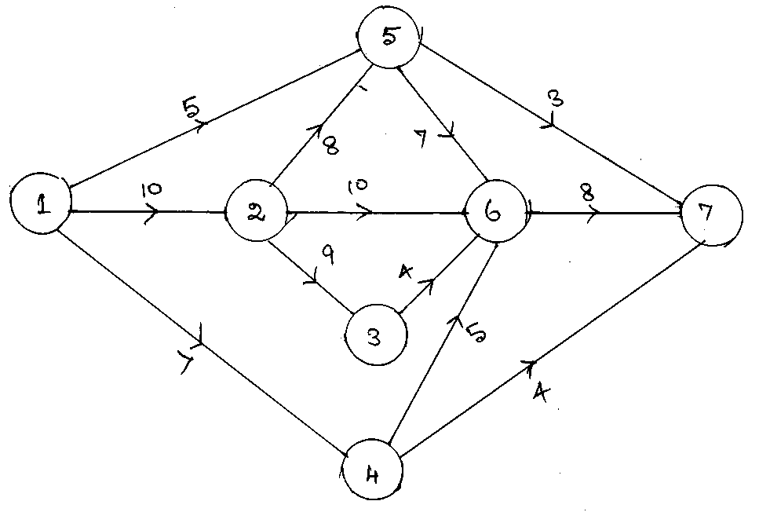

(b) For the following network calculate the length, variance and critical path and find the probability that the project is completed in 41 days. (10)

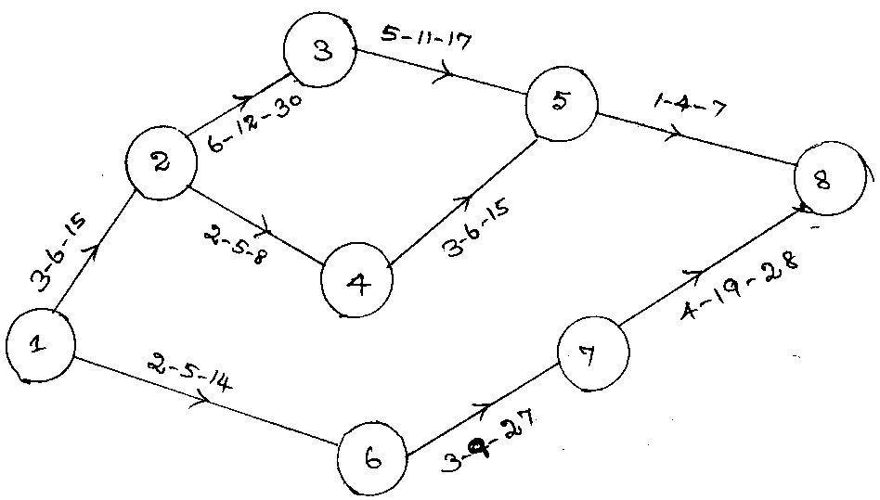

––––––––––––––



DE–2976

**33**

DISTANCE EDUCATION

B.Sc. (Mathematics) DEGREE EXAMINATION, MAY 2008.

NUMERICAL METHODS

Time : Three hours Maximum : 100 marks

Answer any FIVE questions.

Each question carries 20 marks.

1. (a) Find a real root of the equation Cos*x* = 3*x*–1 correct to 3 decimal places by using iteration method.
   1. (b) Find the smallest positive root of  by Regula falsi method.
2. (a) Using Newton-Raphson method, find correct to four decimal places, the root between 0 and 1 of the equation .
   1. (b) Solve the following equations by the method of triangularisation method :
   2. ;
   3. ;
   4. .
3. (a) Find the function whose first difference is .
   1. (b) (i) State and prove Montmorts theorem.
   2. (ii) Given the values :

|  |  |  |  |  |  |
| --- | --- | --- | --- | --- | --- |
| *x* | 5 | 7 | 11 | 13 | 17 |
| *y* | 150 | 392 | 1452 | 2366 | 5202 |

* 1. Evaluate *Y*9  using Lagrange’s formula.

1. (a) Derive Gauss Interpolation formula.
   1. (b) Given :

|  |  |  |  |  |  |  |  |
| --- | --- | --- | --- | --- | --- | --- | --- |
|  |  |  |  |  |  |  |  |
|  | 0 | 0.0875 | 0.1763 | 0.2679 | 0.3640 | 0.4663 | 0.5774 |

* 1. Show that  use Strling’s formula.

1. (a) From the following table of values of *x* and *y* find  and  for *x* = 1.05.

|  |  |  |  |  |  |  |  |
| --- | --- | --- | --- | --- | --- | --- | --- |
| *x* | 1.00 | 1.05 | 1.10 | 1.15 | 1.20 | 1.25 | 1.30 |
| *y* | 1.00000 | 1.02470 | 1.04881 | 1.07238 | 1.09544 | 1.11803 | 1.14017 |

* 1. (b) The elevation above a datum line of seven points of a road are given below :

|  |  |  |  |  |  |  |  |
| --- | --- | --- | --- | --- | --- | --- | --- |
| *x* | 0 | 300 | 600 | 900 | 1200 | 1500 | 1800 |
| *y* | 135 | 149 | 157 | 183 | 201 | 205 | 193 |

* 1. Find the gradient of the road at the middle point?

1. (a) (i) Derive the Simpson’s one third rule on numerical integration?
   1. (ii) Evaluate  using Simpson’s three eight rule.
   2. (b) Evaluate  by Weddley’s rule taking h = 0.1 compare with the actual value and get the numerical difference between them.
2. (a) Using Picard’s method solve  with  
   *y*(0) = 2. Find *y*(0.1), *y*(0.2) and *y*(0.3)?
   1. (b) Given ; *y*(1) = 1. Evaluate *y*(1.3) by modified Euler’s method?
3. (a) Compute *y*(0.1) and *y*(0.2) by Runge – Kutta method of 4th order for the differential equation
   1. ; *y*(0) = 1.
   2. (b) Find y(0.8) by Milne’s method for the equation ; *y*(0) = 1 obtaining the starting values by Taylor’s series method?

——————



**34**

DE–2977

DISTANCE EDUCATION

B.Sc. (Mathematics) DEGREE EXAMINATION, MAY 2008.

COMPLEX ANALYSIS

Time : Three hours Maximum : 100 marks

Answer any FIVE questions.

1. (a) Find the point  on the sphere  that represents the complex number . (10)
   1. (b) Prove that the function  is not differentiable. (10)
2. (a) Find the constant  so that  is harmonic. Find an analytic function  for which  is the real part. Also find its harmonic conjugate. (10)
   1. (b) Discuss the convergence of the power series .   
       (10)
3. (a) Show that by means of the inversion  the circle given by  is mapped into the circle .   
    (10)
   1. (b) Determine the bilinear transformation which maps 0, 1, , into , –1, –1 respectively. Under this transformation show that the interior of the unit circle of the -plane maps onto the half plane left to the -axis. (10)
4. (a) Prove that any bilinear transformation which maps the unit circle  onto the unit circle  can be written in the corm  where  is real. Also prove that this transformation maps the circular disc  onto the circular disc  iff . (12)
   1. (b) Prove that the transformation given by  maps the unit circle  onto the unit circle  1 if . (8)
5. (a) Show that  where  is the square with vertices , ,  and . (10)
   1. (b) Let  be a function which is analytic inside and on a simple closed curve . If  is an interior point of   
       prove that . (10)
6. (a) State and prove that Liouville’s theorem. (7)
   1. (b) Show that when  is analytic within and on a simple closed curve  and  is not on  then . (13)
7. (a) If  find Laurent’s series expansions in (i)  and (ii) . (10)
   1. (b) Find the residue of  at . (10)
8. Using the method of Cantour integration evaluate . . (20)

————————



**35**

DE–2978

DISTANCE EDUCATION

B.Sc. (Mathematics) DEGREE EXAMINATION, MAY 2008.

DISCRETE MATHEMATICS

Time : Three hours Maximum : 100 marks

Answer any FIVE questions.  
 (5 × 20 = 100)

1. (a) Draw the parsing tree for the formula
   1. 
   2. (b) Construct the truth table for .
2. (a) Show that  is a tautology.
   1. (b) Obtain a disjunctive normal form of
   2. .
3. (a) Derive , using the rule of conditional proof if necessary, from , .
   1. (b) Using indirect proof, show that
   2. .
4. (a) Write each of the following in symbolic form
   1. (i) All men are giants
   2. (ii) No men are giants
   3. (iii) Some men are giants
   4. (iv) Some men are not giants.
   5. (b) Verify the validity of the following arguments :
   6. Lions are dangerous animals. There are lions.
   7. Therefore there are dangerous animals.
5. (a) (i) Define a ‘Simple graph’.
   1. (ii) Let G be a graph, then , where .
   2. (b) A graph *G* is disconnected if and only if its vertex set *V* can be partitioned into two non-empty subsets  and  such that there exists no edge in *G* whose one end vertex is in  and other in  prove.
6. (a) Let *r* be a positive integers. Let *A* be the adjacency matrix of a simple graph *G*. Then the  entry in  is the number of different walks of length *r* between the vertices  and  – Prove.
   1. (b) Obtain the adjacency matrix A of digraph given below. Find the elementary paths of length 1 and 2 from   
       to .

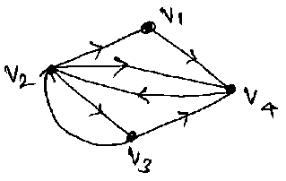

1. (a) (i) Define a ‘cut-set’.
   1. (ii) Every cut-set in a connected graph *G* must contain atleast one edge of every spanning tree of *G* – Prove.
   2. (b) (i) Define ‘Fundamental cut set’.
   3. (ii) Let *T* be a spanning tree of a connected   
      graph *G*. Let *C* be a chord of *T* and  be the fundamental circuit determined by *C*. Then *C* occurs in every fundamental cut set associated with the edges in  and in no other ­ – Prove.
2. (a) State and prove the ‘Max-flow min-cut’ theorem.
   1. (b) Prove that, if a connected plane graph *G* has   
      *n* vertices, *e* edges and *f* faces, then .

————————